4/14/2021

Nadir Hussain

023-18-0025

Computer Networks

Lab 06

**Lab Objectives:**

* ***Create a network of 3 different PCS on different networks, connect a virtual network by loopback and use RIP protocol to perform dynamic routing on each router , Also check the connectivity by ping command.***
* ***Practice multi area OSPF protocol, connect a virtual network to any area and test the connectivity by ping or show by routing table***

**Task1:**

**Create a network of 3 different PCS on different networks, connect a virtual network by loopback and use RIP protocol to perform dynamic routing on each router , Also check the connectivity by ping command.**

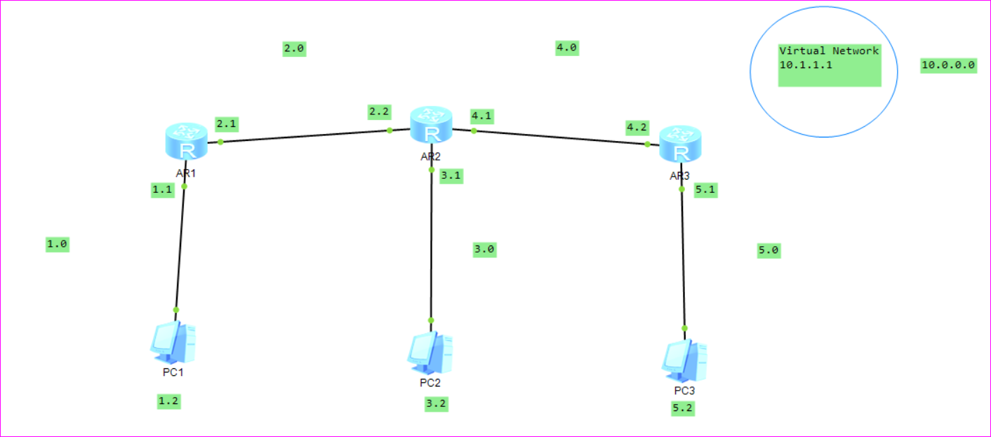

**Configure all PCs**

**For PC1**

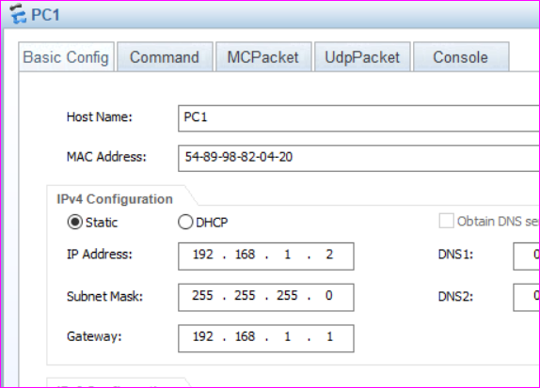

*Similarly configure PC1 and PC3*

**Configure all interfaces**

**On Router 1**

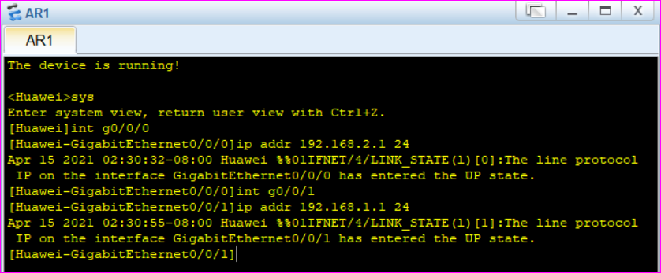

**On Router2**

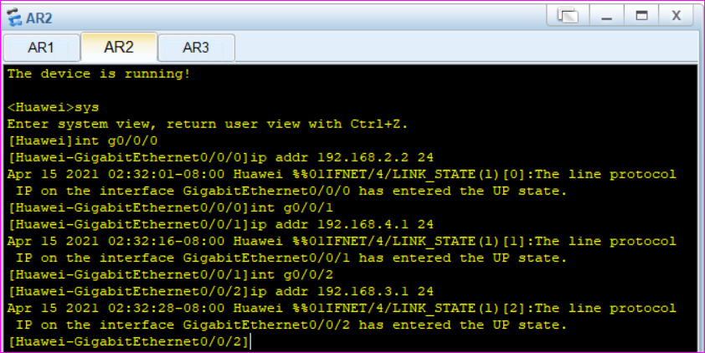

**On Router3**

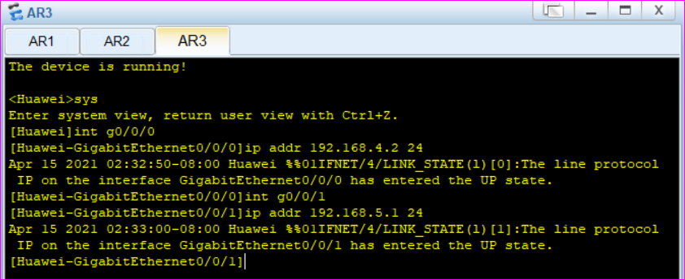

**Connect virtual interface with Router 3**

*Choosing virtual interface*

*Int lo0*

*Int lo500 //Create atleast 500 loopbacks*

*Int lo01024 //It will not be created, we have 1023 virtual interfaces*

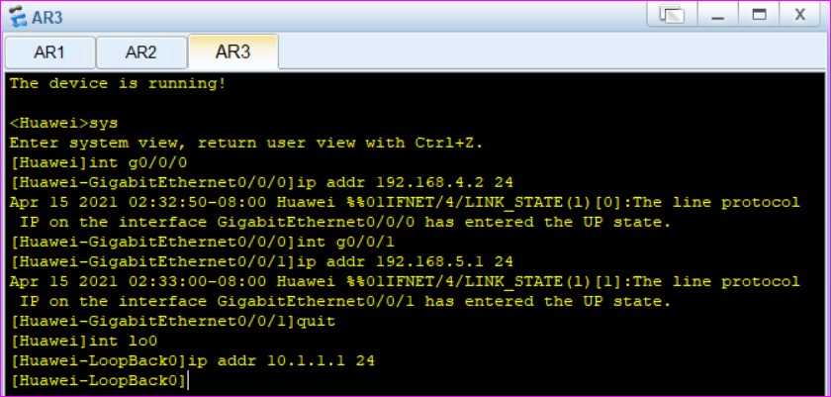

***Now its configured, We need to configure the routers dynamically***

***OSPF requires info from all network, RIP needs only from directly connected nodes.***

***On router, we configure networks with RIP protocol***

**On router1**

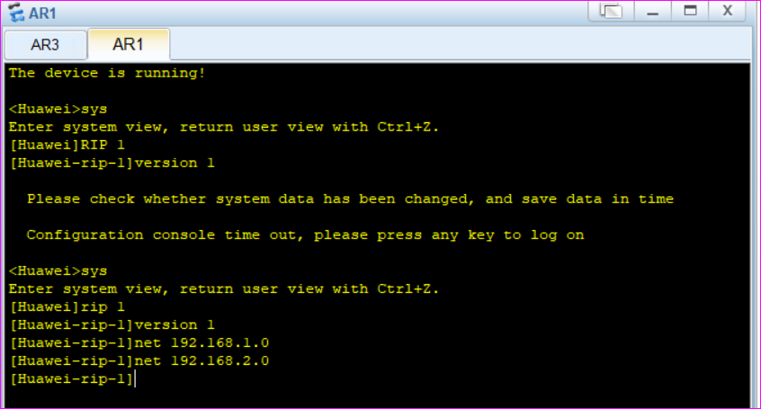

**On router 2**

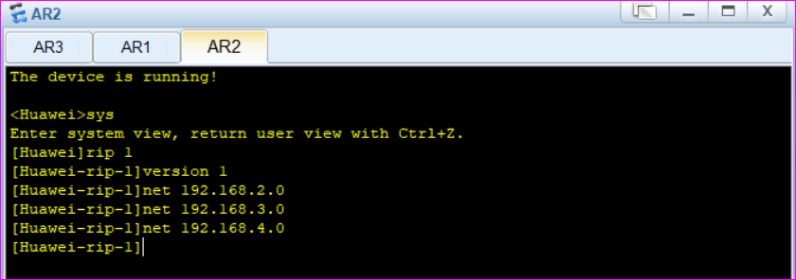

**On router 3, we also configure virtual network**

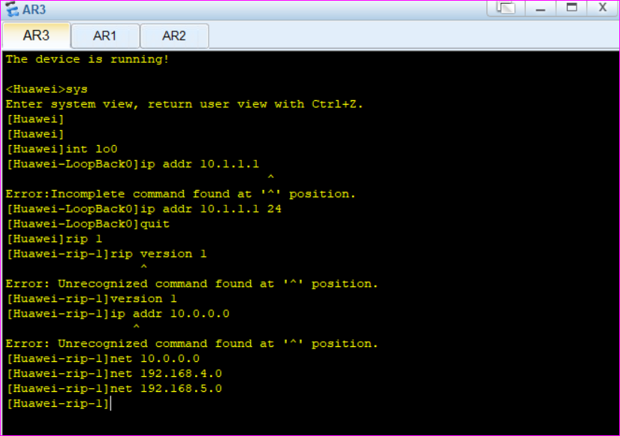

**Now we test our network by ping command**

**From PC1 to PC3**

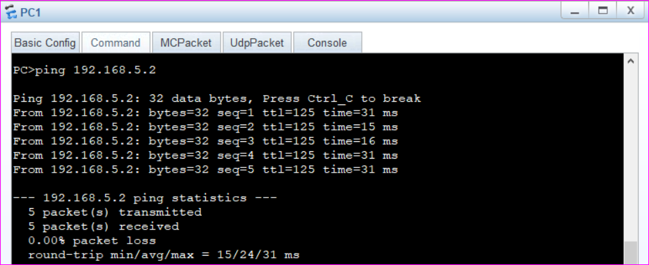

**From PC1 to Virtual network**

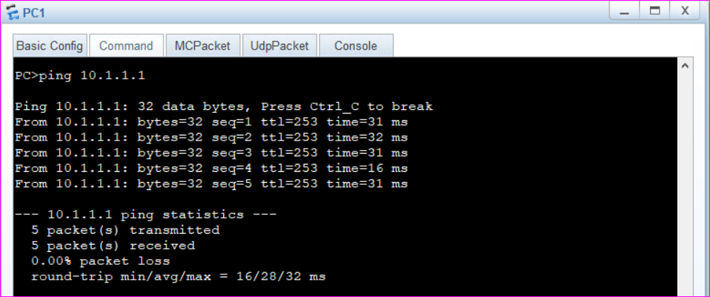

***Or***

***We can simply check routing table to know if all networks are connected, including virtual interface on router 3***

**Routing table of router 1**

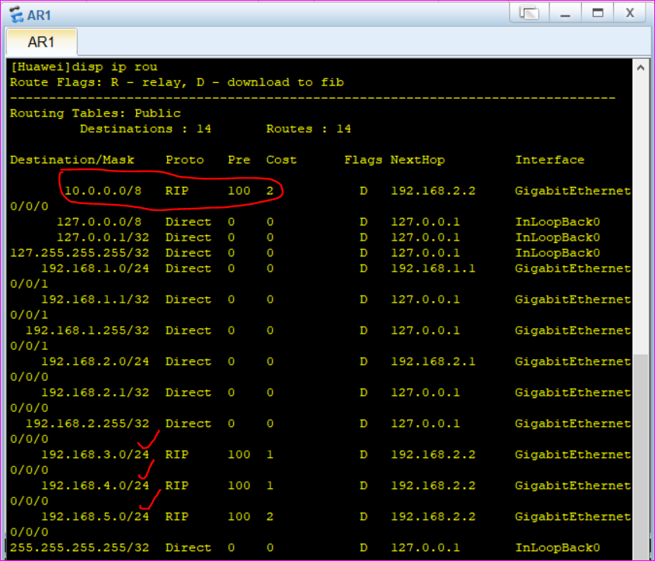

**Routing table of router 2**

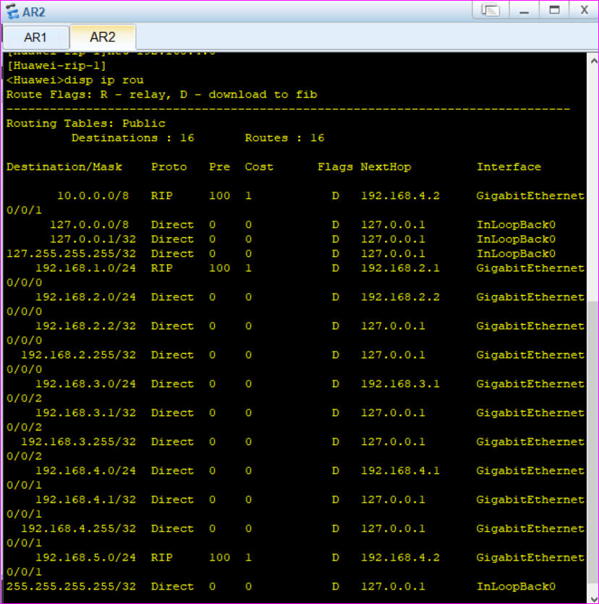

**Routing table of router3**

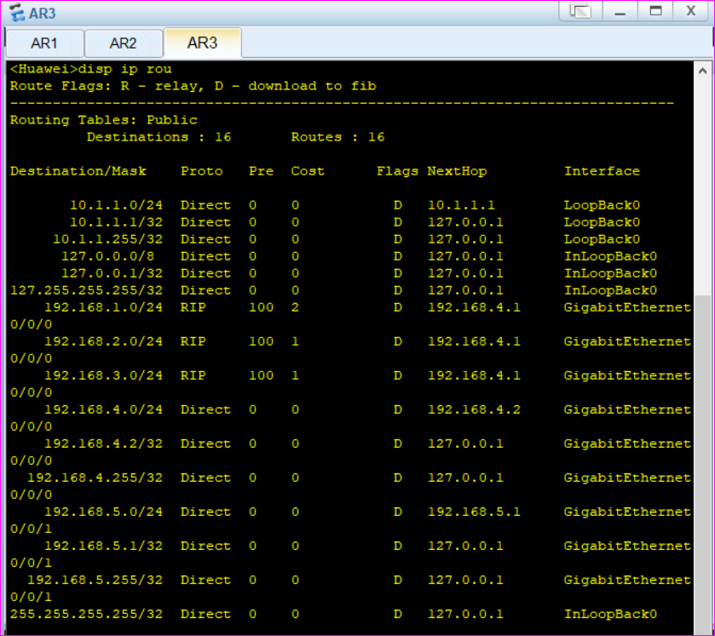

**What if we have performed dynamic routing on router1, and want to cancel it?**

***We can undo RIP***

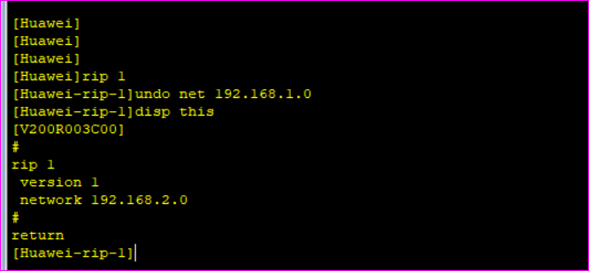

**Task2:**

**Practice multi area OSPF protocol, connect a virtual network to any area and test the connectivity by ping or show by routing table**

Designing multi area OSPF

**Network design**

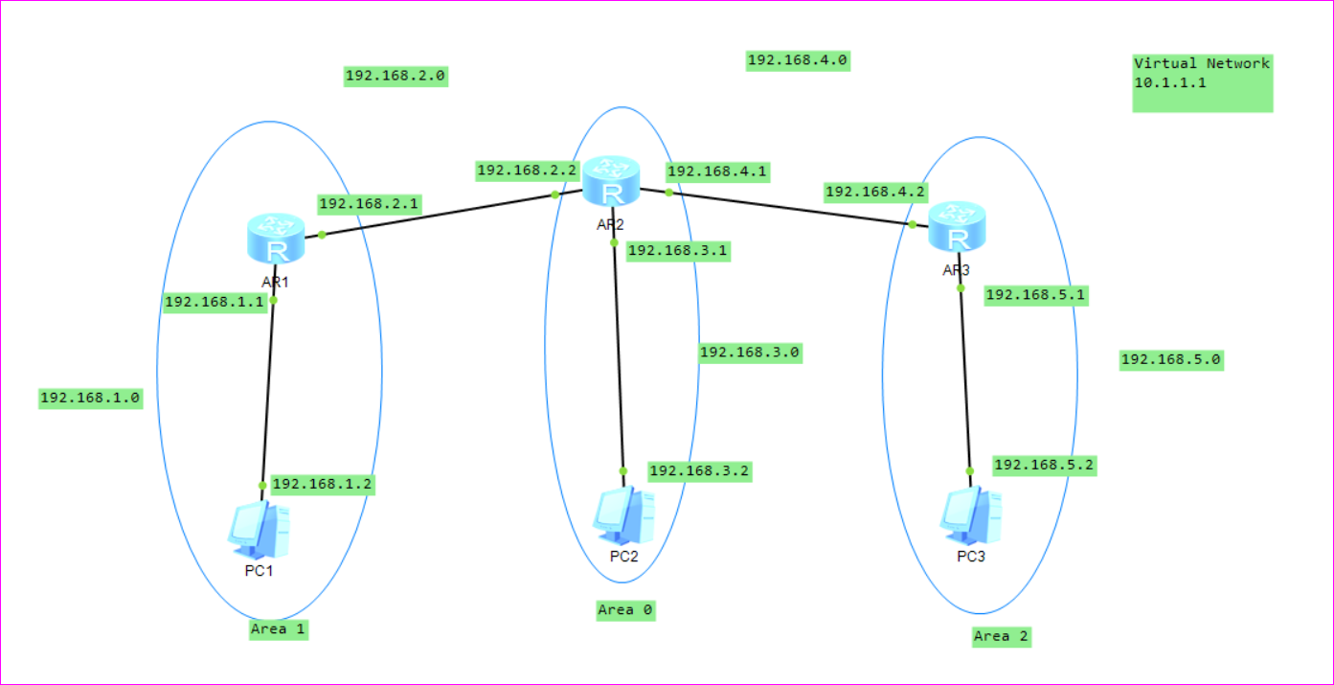

**Set Configuration for each PC**

**Set interface configurations**

We have defined 3 areas, Area 0 is core network i.e Area1 and Area2 can only communicate if they have access to area0

Now we configure multi area ospf

On Router1

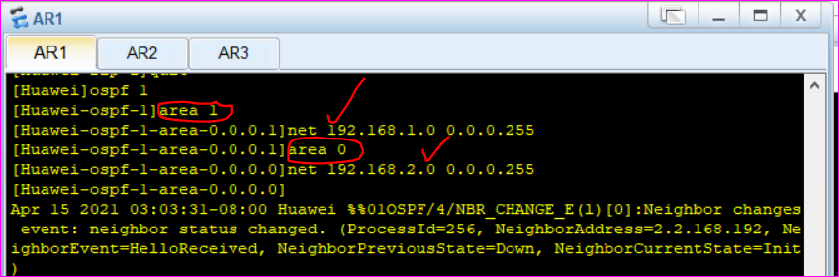

On router2

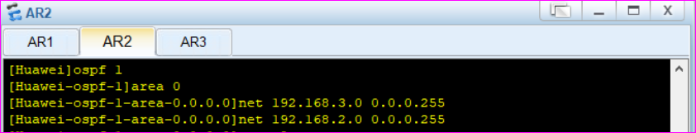

When we add 192.168.2.0 to area0 on router2 we observed advertisement on router2 and router1

Advertisment on router2

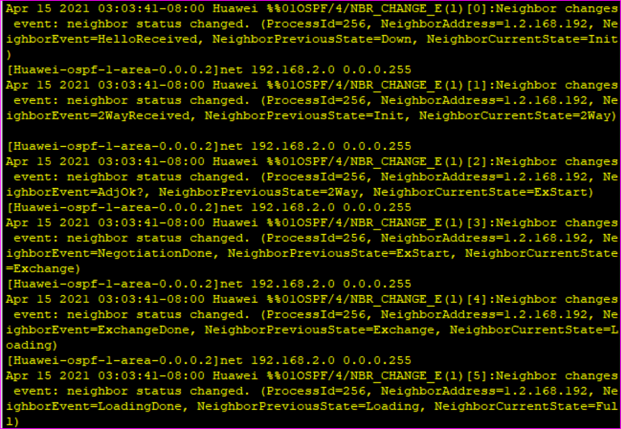

Advertisment on router1

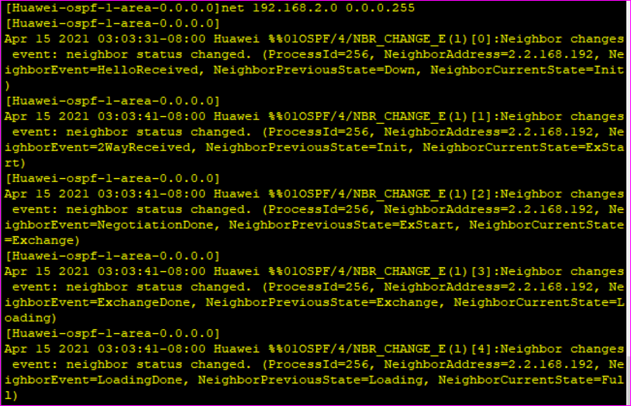

Now we add 192.168.4.0 to area2 on router 2

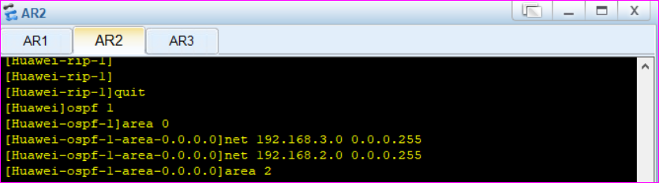

Now on router3

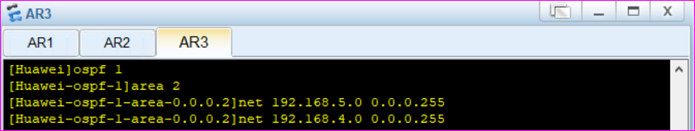

When we added 192.168.4.0 in area2 on router 3 we observed an advertisement on router2 and router3

Now we add 10.0.0.0 to area2 as well

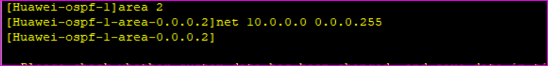

Now all networks are connected, we test by ping from PC1 to PC3 and from PC1 to virtual network

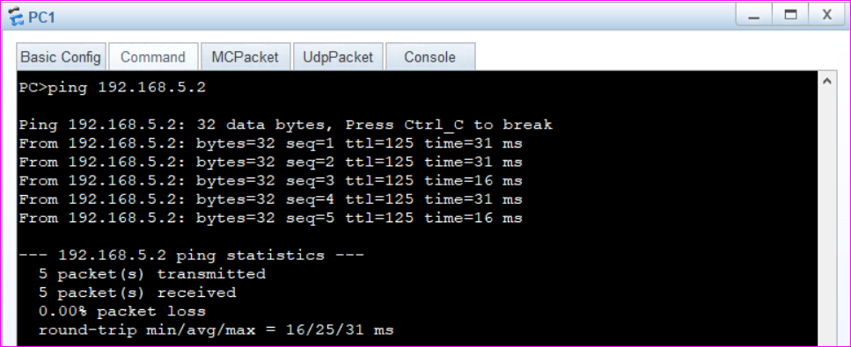

From PC1 to Virtual Netwrok

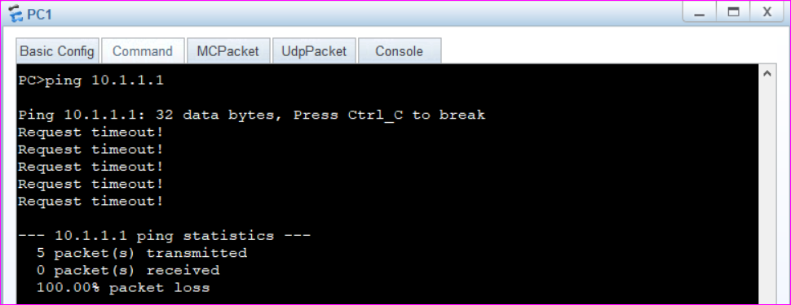

Notice that network 3 is still not connected.

We should add loopback ip to 10.0.0.0 network as

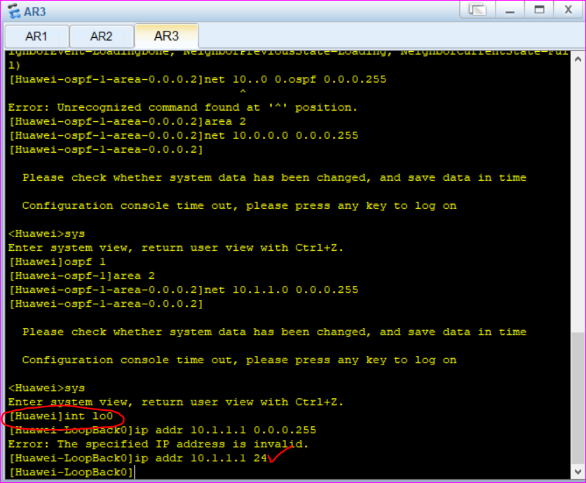

Now we ping from PC1 to virtual network

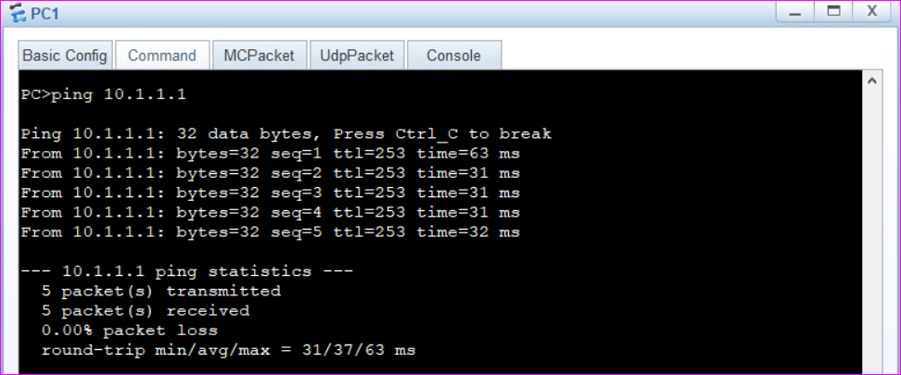

**Or we can simply show the routing table**

**On router1**

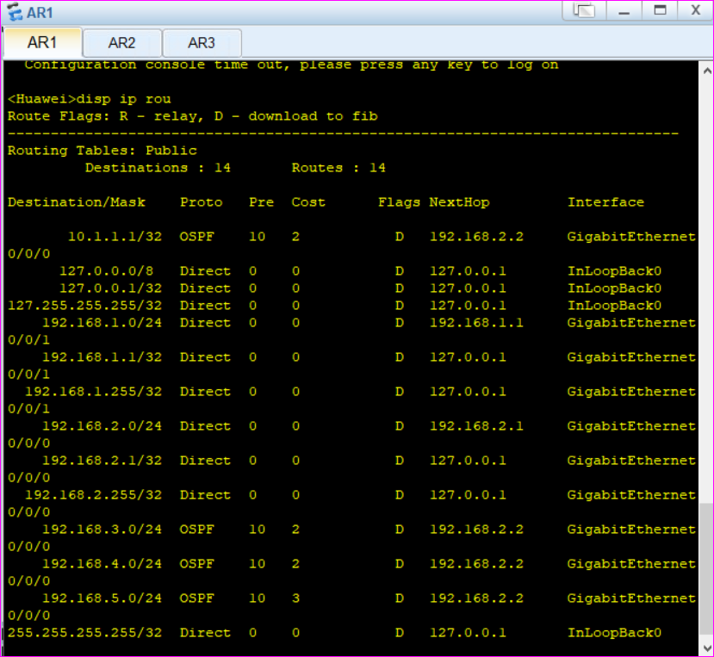

**On Router2**

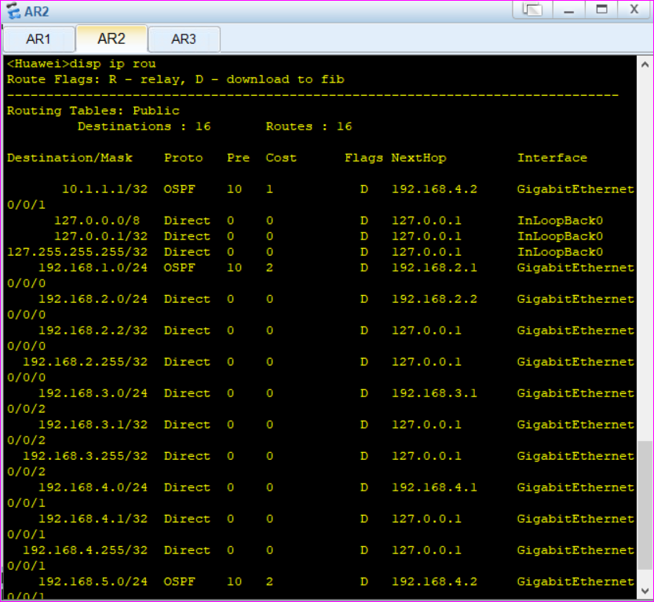

**On Router3**

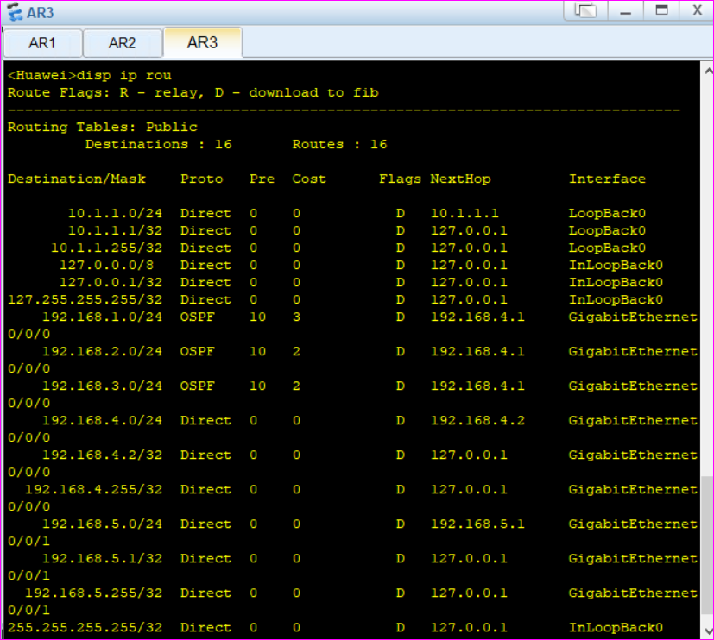

**The End**